THE OSLO DIARIES
A film by Mor Loushy and Daniel Sivan

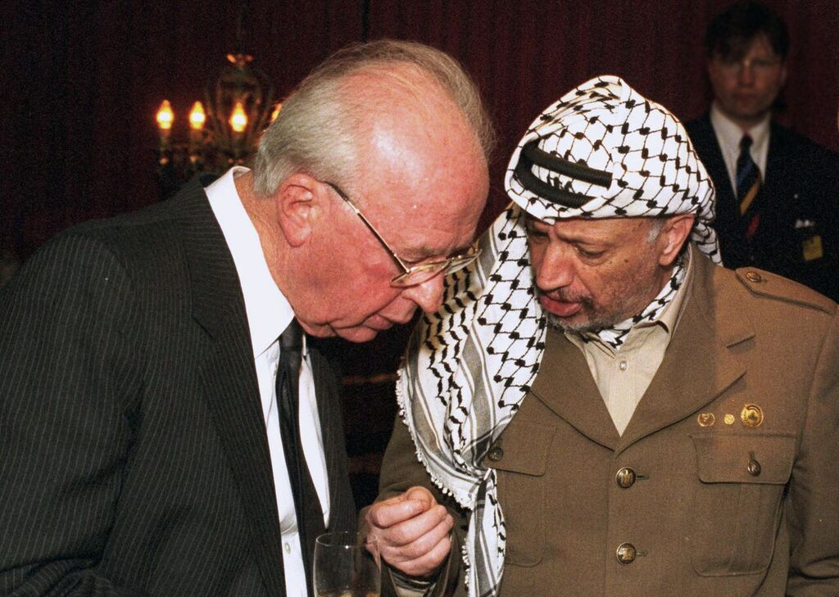

Runtime: 94 minutes
Country of Origin: Israel/Canada
Language: English and Hebrew/Arabic
Genre: Documentary
Unrated

FESTIVALS AND SCREENINGS:
Docs for Education
Nahum Laufer
laufern@netvision.net.il
+972.04.659.1119

SALES CONTACT: PRODUCER CONTACT:
Submarine Medalia Productions
Ben Braun Hilla Medalia
ben@submarine.com hilla@medaliaproductions.com
+1.212.625.1410 +972.54.479.1124 / 1.917.650.0084

SYNOPSIS

In 1992, with Israeli-Palestinian relations at an all-time low and any communication punishable with jail time, a small group of Israelis and Palestinians gathered in Oslo – secretly and against the law. Although the meetings that came to be known as The Oslo Accords changed the Middle East forever, they were never officially sanctioned and were chronicled only by the negotiators' diaries.

In The Oslo Diaries, directors Mor Loushy and Daniel Sivan (Censored Voices, Sundance 2015) bring us a riveting account of 1100 days of secret talks as told by the people who were there at the table. The participants’ detailed and often emotional entries recount the political intrigue, fiery rhetoric, unlikely friendships, and overwhelming desire for peace that were the heart of the negotiations.

Featuring never-before-seen footage and exclusive interviews with key players - including the last on-camera conversation with former Israeli president Shimon Peres - the film recounts a geopolitical story, with a narrative voice that is personal and philosophical. Although politics ultimately doomed The Oslo Accords, the story’s end for the people of Israel and Palestine remains unwritten.

DIRECTORS’ STATEMENT

BY MOR LOUSHY AND DANIEL SIVAN

When a child is born in Israel, even before he's given a name, he already has a destiny which is set in stone: when he grows up he will become a soldier. This destiny is known to all, as most parents have been soldiers themselves. When we were born, back in the early 80s, our parents told us the same lie all Israeli parents give their children: "When you grow up you won't go to the army" they said, "There will be no need for an army, as we will have peace with our neighbors." Now that we are parents ourselves, we find ourselves telling our children the exact same lie. For generations Israelis have been dreaming of peace and failing to achieve it. Our question is "why?"

The Oslo Diaries is our personal journey, back to the one decisive moment that almost changed our history. A tipping point in which two sworn enemies had taken a leap of faith that seems unimaginable nowadays. Striving to understand why we keep failing in peacemaking, we have uncovered a passionate story of the people who didn't fail, but have created bridges and friendships where only bullets and hatred were previously exchanged. This is not a fantasy tale and like all tales in the Middle East, it is complex: The Israelis were not equals to the Palestinians, but an occupying nation; Yasser Arafat and Yitzhak Rabin did not become soul mates and kept distrusting each other until their last days; and these years of hope and prosperity were also filled with violence and oppression - and yet there was hope. Hope like never before. You could feel in the air the ground was changing, that we were transitioning into a new Middle East, to a life of true co-existence. Sadly, this sense of change did not escape the extremists who had fought peace on both sides like never before - and won.

The tragic ending of this story is known to us all too well, as peace has not come to our region. And yet, we wish that the audience will see past the tragedy and into that moment of hope, as peace was in the making and enemies had become partners. Despite all the complexities the answer is so simple: we are all human, we all want to live good lives and raise our children on this small piece of land, we all deserve to live together in equality, without walls and hatred, without lying to our children about the future - but fighting side by side for a life in which no Israeli child is destined to become a soldier and no Palestinian child is destined to fear him. It is our duty as filmmakers, as Israelis and Palestinians, but most of all as parents, to fight for a different reality and to never give up, as peace between Israel and Palestine is not a dream, but our future.

CREW BIOGRAPHIES

MOR LOUSHY (Director/Co-Producer/ Editor)

Mor Loushy is an award-winning Israeli director. Her debut film, Israel Ltd (2009), premiered at IDFA and was broadcast worldwide. Her latest documentary, Censored Voices (2015), won an Ophir Award for best documentary. Censored Voices premiered at Sundance Film Festival and screened at BFI London and IDFA and released theatrically worldwide.

DANIEL SIVAN (Director/Co-Producer/Editor)

Daniel Sivan is an award-winning Israeli director/producer known for his critical social-political documentaries. His works include Censored Voices (Sundance, Berlinale, BFI), Offside (Tribeca, IDFA), and The Patriot. He recently edited Death in the Terminal (executive produced by Mark Boal and Megan Ellison)—winner of an Ophir Award and a Hot Docs best mid-length documentary award.

HILLA MEDALIA (Producer)

Peabody Award-winning filmmaker Hilla Medalia has received three Emmy® nominations. Her projects have garnered critical acclaim and screened internationally in theaters and on television, including HBO, MTV, BBC, and ARTE. Her range of titles include To Die in Jerusalem 2007 (HBO), After the Storm 2009 (MTV), Numbered 2012 (ARTE), Dancing in Jaffa 2013 (Tribeca, IFC Sundance selects), Web Junkie 2014 (Sundance Film Festival, POV (PBS), BBC), The Go Go Boys 2014 (Cannes Film Festival), Censored Voices 2015 (Sundance Film Festival, Berlinale), Muhi – Generally Temporary 2017 (SF Film Festival, HotDocs, IDFA), and The Oslo Diaries 2018 (Sundance Film Festival).

Hilla is a mentor for the NFCT’s Business Card Program for Emerging Filmmakers, where she acts as lector and judge at film festivals and forums. She is also a member of The American Academy of Motion Picture Arts and Sciences, The Israeli Academy of Film and Television, and a board member of The Israeli Director's Guild. Medalia holds a Master of Arts from Southern Illinois University.

INA FICHMAN (Producer)

For twenty-five years, veteran producer/ executive producer Ina Fichman has been producing award-winning documentary and fiction films for Intuitive Pictures, a Montreal-based company specializing in international co-productions that is dedicated to producing quality film, television, and interactive productions. Some critically acclaimed features produced by Intuitive Pictures in the recent years included Mabul (The Flood), Monsoon, The Wanted 18, and Vita Activa: The Spirit of Hannah Arendt. Interactive productions include the web project 100% TShirt, the interactive graphic novel The Wanted 18, and Space Advisor: a Guide to Space Tourism. Intuitive Pictures recently completed the documentary Game Fever and the company’s current productions include Laila at the Bridge, The Oslo Diaries, The Patriot, Shekinah 2, and Gift.
Ina currently sits on the boards of the CMPA, Canada’s producers’ association and DOC Quebec. She is a founder of FCTNM (Montreal Women in Film) and WIFTI ( Women in Film and TV International).

MAIN CREDITS:
Directed by
Mor Loushy
Daniel Sivan

Produced by
Hilla Medalia
Ina Fichman

Co-Produced by
Daniel Sivan
Mor Loushy
Kristian Mosvold

Executive Producers
Guy Lavie
Koby Gal Raday
Danna Stern
Dagmar Mielke
Barbara Dobkin
Jean Tsien

Edited by
Daniel Sivan
Mor Loushy

Original Music
François Jolin

Directors of Photography

Sound Design
Sylvain Bellemare

Re- Avner Shahaf
Alex Margineanu
recording Mixer
Michel Gauvin

